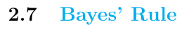

Total Probability

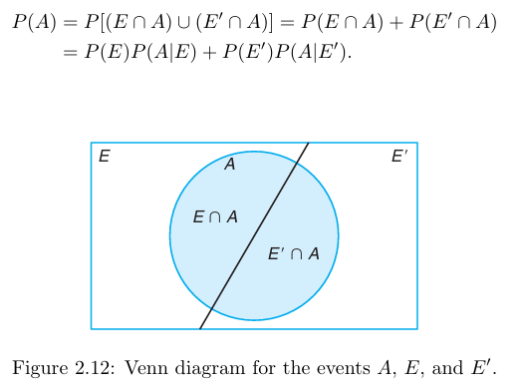
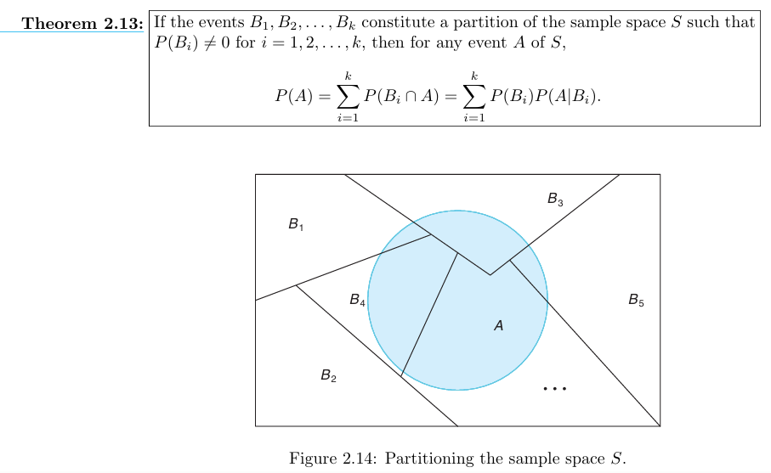

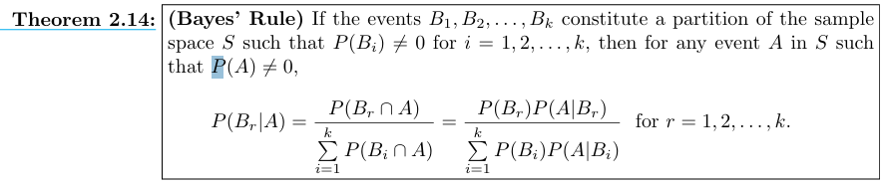

2.95
In a certain region of the country it is known from past experience that the probability of selecting an adult over 40 years of age with cancer is 0.05. If the probability of a doctor correctly diagnosing a person with cancer as having the disease is 0.7 8 and the probability of incorrectly diagnosing a person without cancer as having the disease is 0.06, what is the probability that an adult over 40 years of age is diagnosed as having cancer?
Solution:
P(C) = 0.05
P(D/C) = 0.78
P ( D/C ‘ ) = 0.06
P(D)=?
By theorem 2.13
P(D) = P(C n D) U P(C ‘ n D) = P(C) P(D/C) + P(C ‘ ) P(D/ C ‘ )
P(C ‘ ) = 1- P(C) = 0.95
P(D)= (0.05) (0.78) + (0.95) (0.06) = 0.096

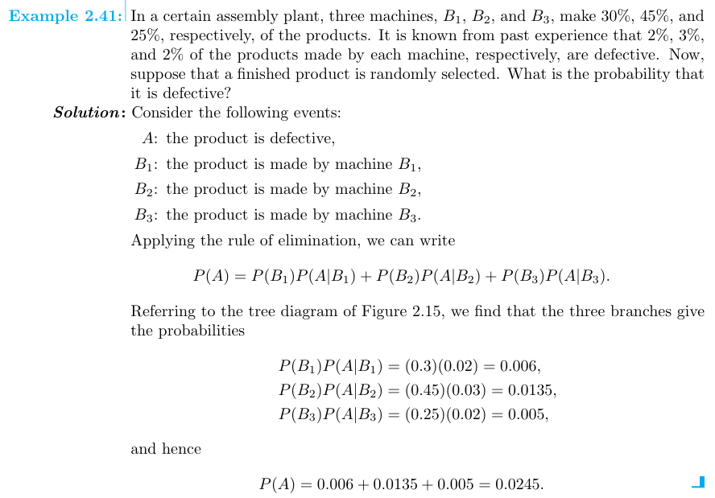
2.96
Police plan to enforce speed limits by using radar traps at four different locations within the city limits. The radar traps at each of the locations L1, L2, L3, and L4 will be operated 40%, 30%, 20%, and 30% of the time. If a person who is speeding on her way to work has probabilities of 0.2, 0.1, 0.5, and 0.2, respectively, of passing through these locations, what is the probability that she will receive a speeding ticket?
Solution:
The radar traps at the locations L1
= (40%) (0.2) = (0.4) (0.2) = 0.08
The radar traps at the locations L2
= (30%) (0.1) = (0.3) (0.1) = 0.03
The radar traps at the locations L3
= (20%) (0.5) = (0.2) (0.5) = 0.1
The radar traps at the locations L4
= (30%) (0.2) = (0.3) (0.2) = 0.06

2.97
Referring to Exercise 2.95, what is the probability that a person diagnosed as having cancer actually has the disease?
Solution:
P(C/D) = ?
P(C/D) = P(C n D)/P(D)

